## **Module 2 Assignment: JavaScript language**

Saurabh Kale

IFT 458/554: Middleware Programming & Database Security

Dinesh Sthapit

Sep 3rd, 2023

## **Module 2 Assignment: JavaScript language**

**Introduction to Javascript - 1**

* Screenshot of Hello There-  
  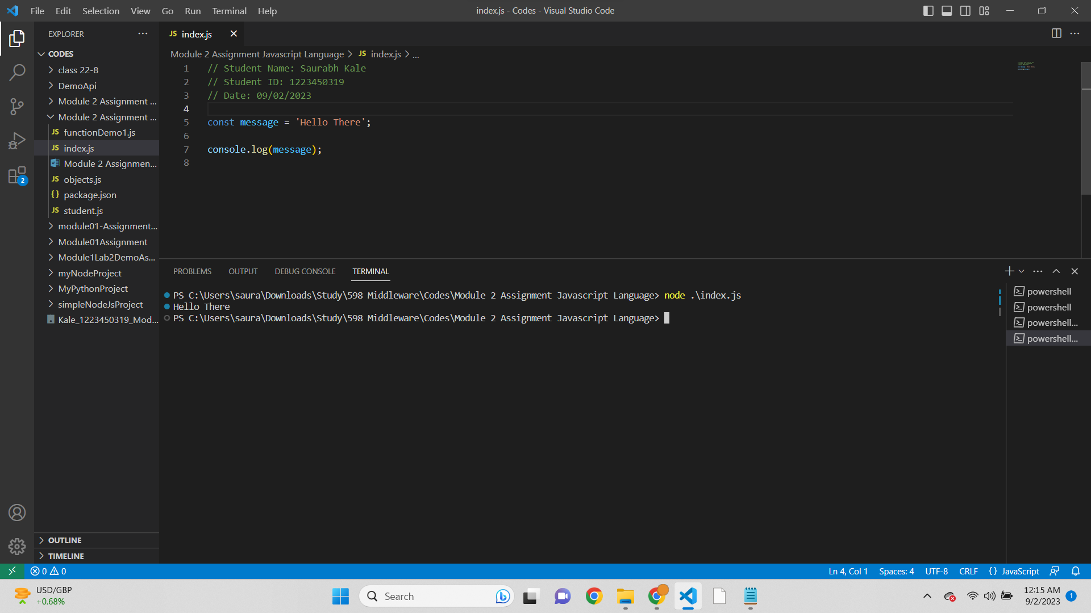

Script-  
// Student Name: Saurabh Kale

// Student ID: 1223450319

// Date: 09/02/2023

const message = 'Hello There';

console.log(message);

Output-  
Hello There

* Screenshot of studentName and Message -

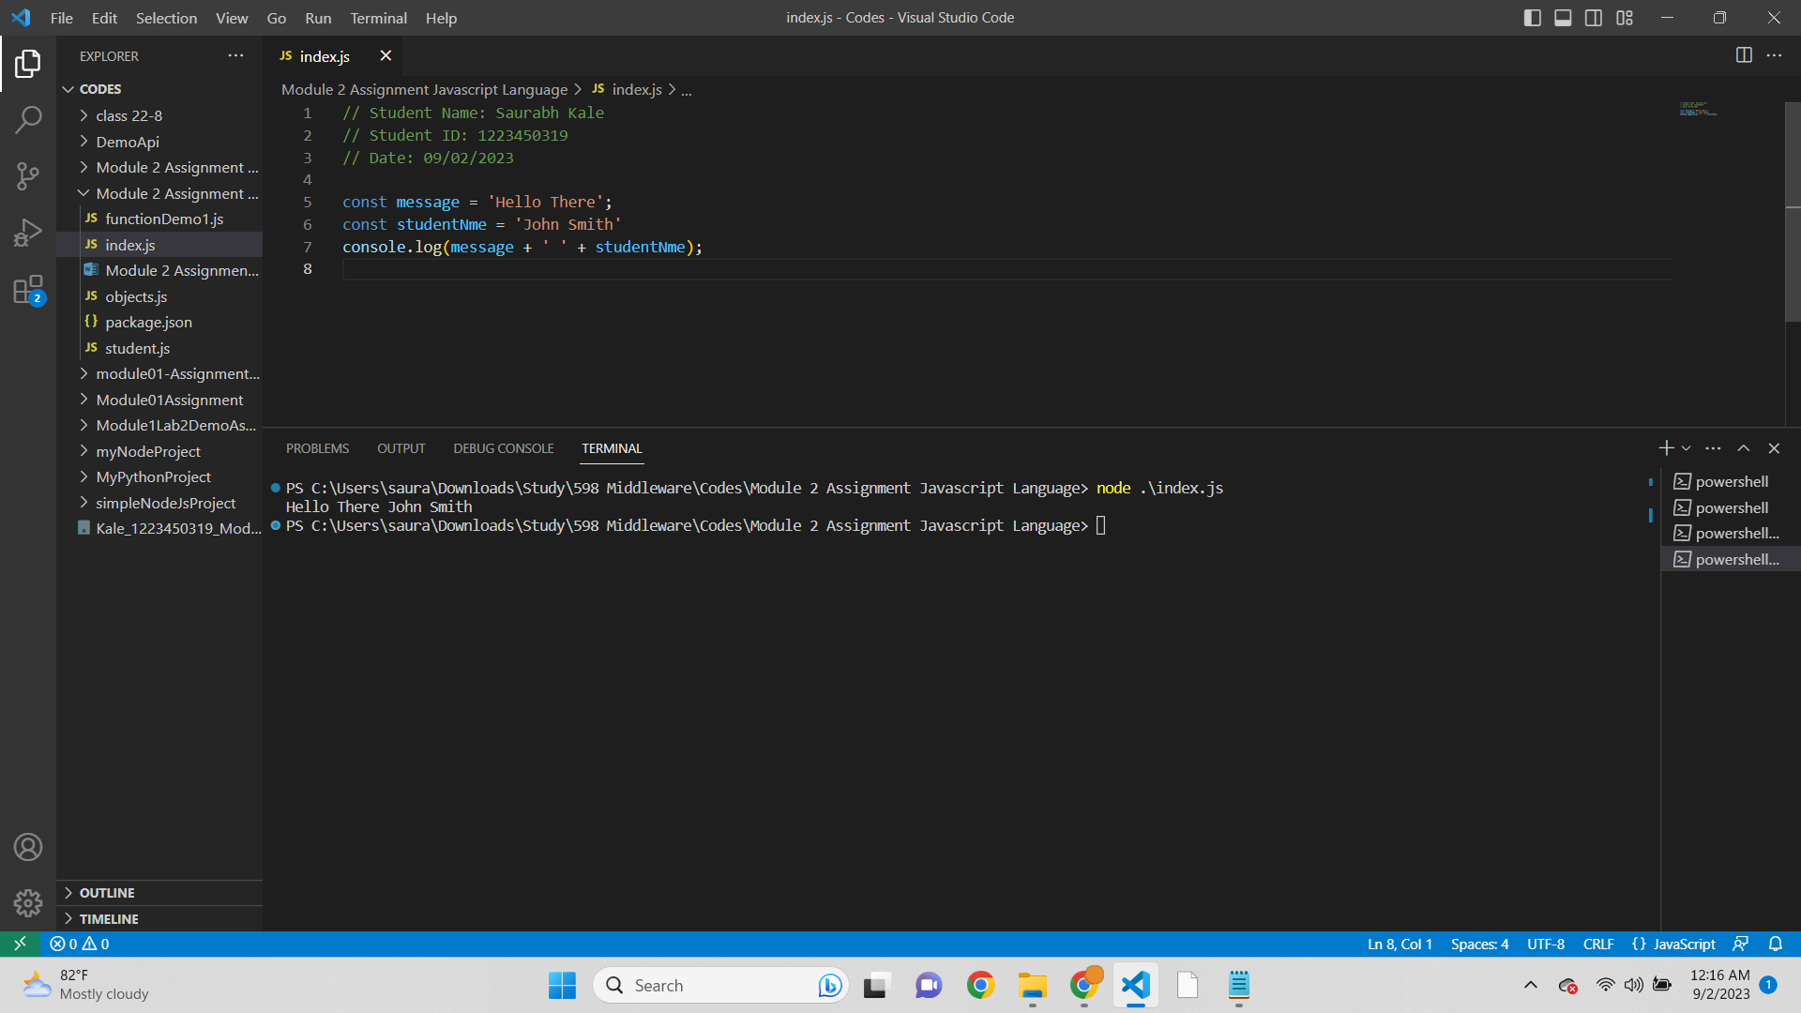

Script-  
// Student Name: Saurabh Kale

// Student ID: 1223450319

// Date: 09/02/2023

const message = 'Hello There';

const studentNme = 'John Smith'

console.log(message + ' ' + studentNme);

Output-  
Hello There John Smith

* Screenshot of greetTheStudent-  
  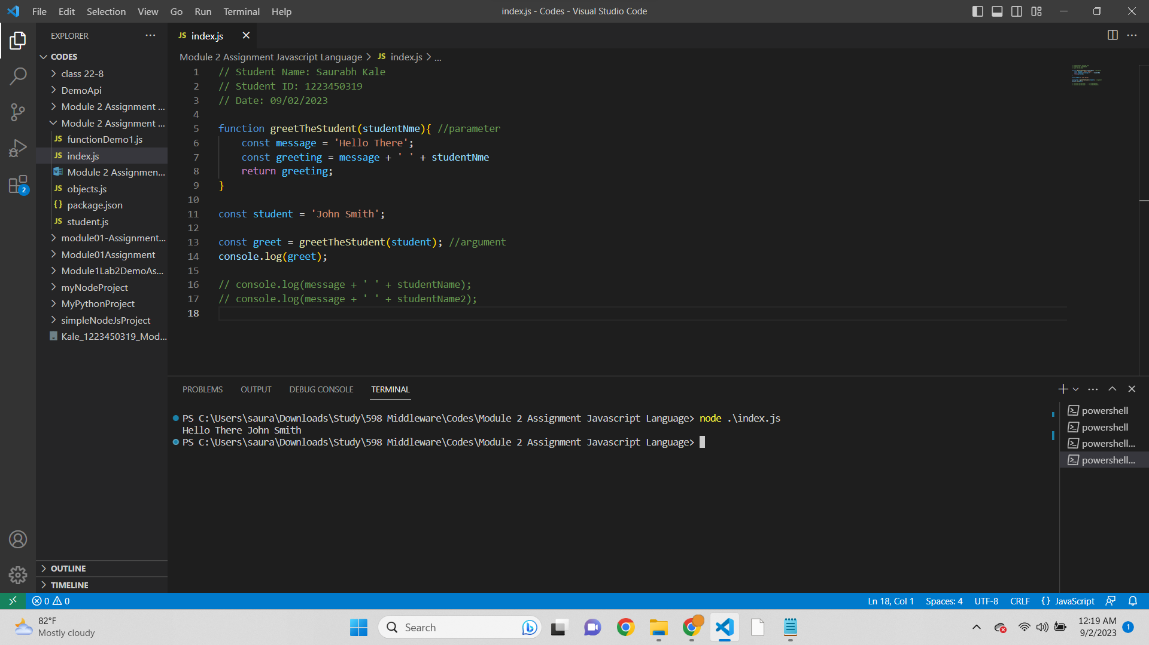

Script-  
// Student Name: Saurabh Kale

// Student ID: 1223450319

// Date: 09/02/2023

function greetTheStudent(studentNme){ //parameter

const message = 'Hello There';

const greeting = message + ' ' + studentNme

return greeting;

}

const student = 'John Smith';

const greet = greetTheStudent(student); //argument

console.log(greet);

// console.log(message + ' ' + studentName);

// console.log(message + ' ' + studentName2);

Output-  
Hello There John Smith

* Refactored Code-

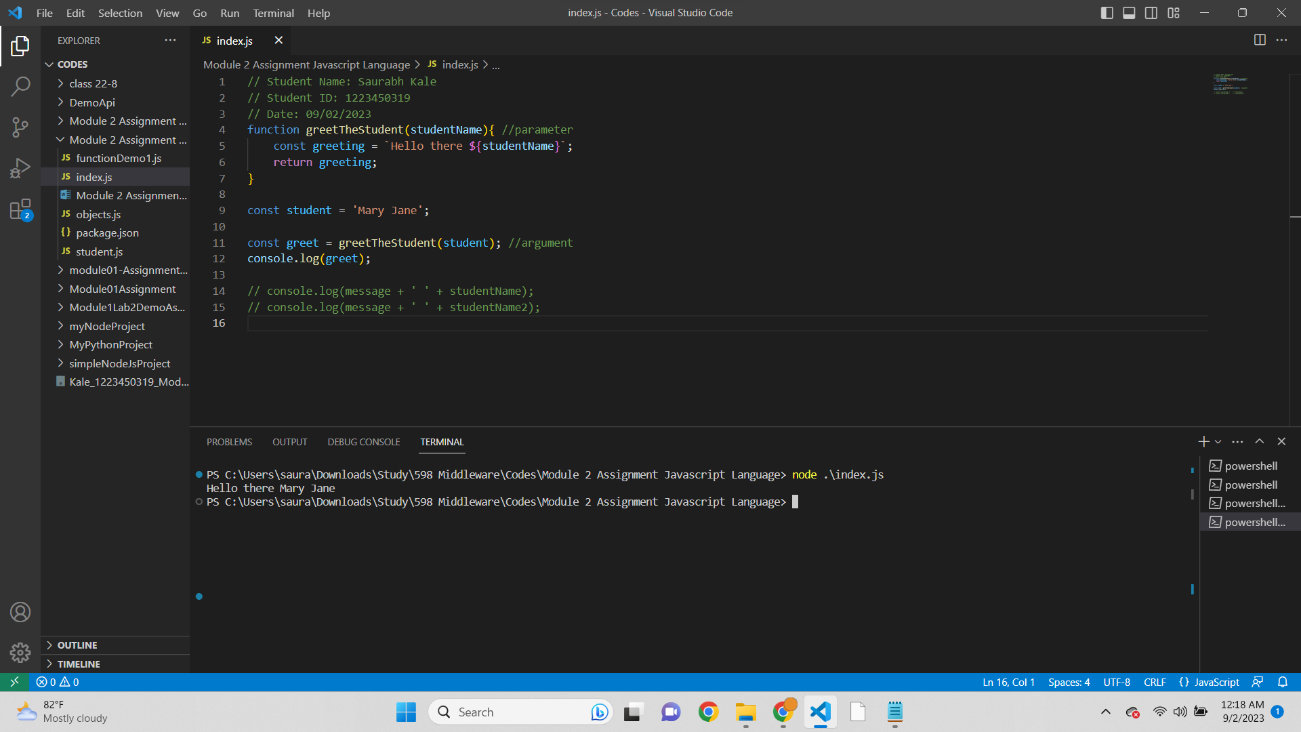

Script-  
// Student Name: Saurabh Kale

// Student ID: 1223450319

// Date: 09/02/2023  
function greetTheStudent(studentName){ //parameter

const greeting = `Hello there ${studentName}`;

return greeting;

}

const student = 'Mary Jane';

const greet = greetTheStudent(student); //argument

console.log(greet);

// console.log(message + ' ' + studentName);

// console.log(message + ' ' + studentName2);

Output-  
Hello there Mary Jane

* DRY Concept-  
  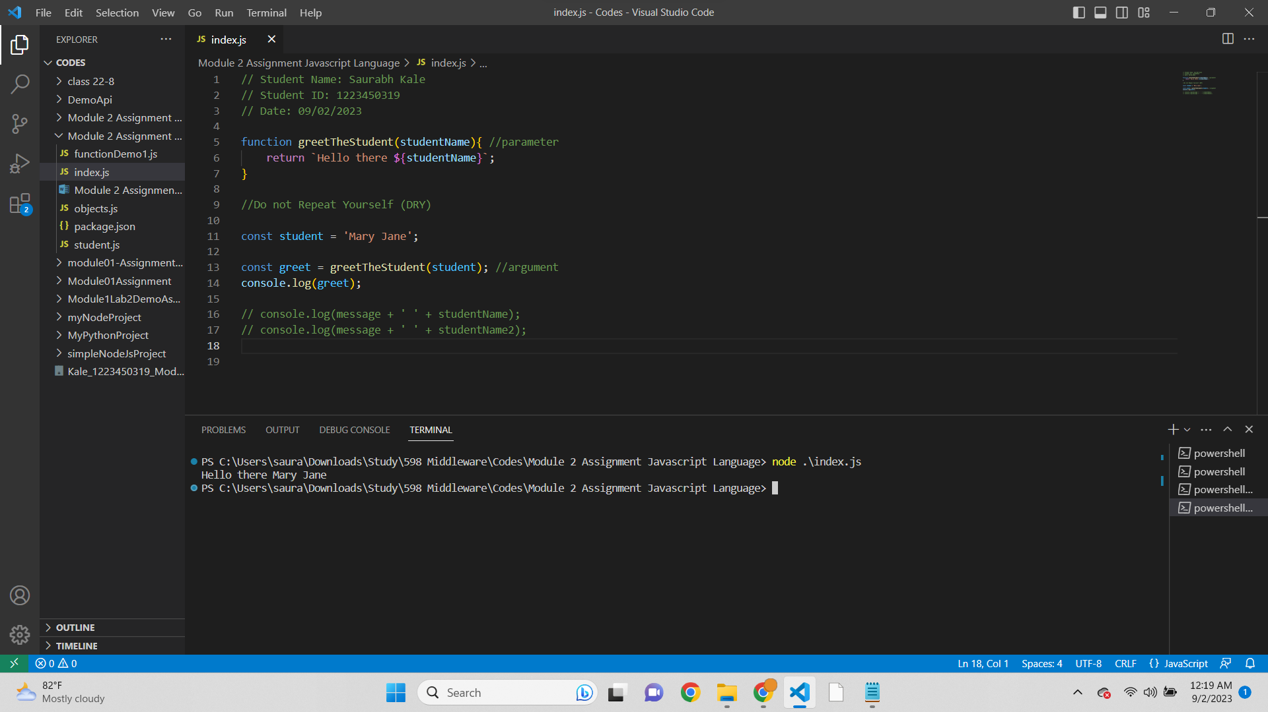

Script-  
// Student Name: Saurabh Kale

// Student ID: 1223450319

// Date: 09/02/2023

function greetTheStudent(studentName){ //parameter

return `Hello there ${studentName}`;

}

//Do not Repeat Yourself (DRY)

const student = 'Mary Jane';

const greet = greetTheStudent(student); //argument

console.log(greet);

// console.log(message + ' ' + studentName);

// console.log(message + ' ' + studentName2);

Output-  
Hello there Mary Jane

**JavaScript Function Refactoring 2**

* Anonymous Function-

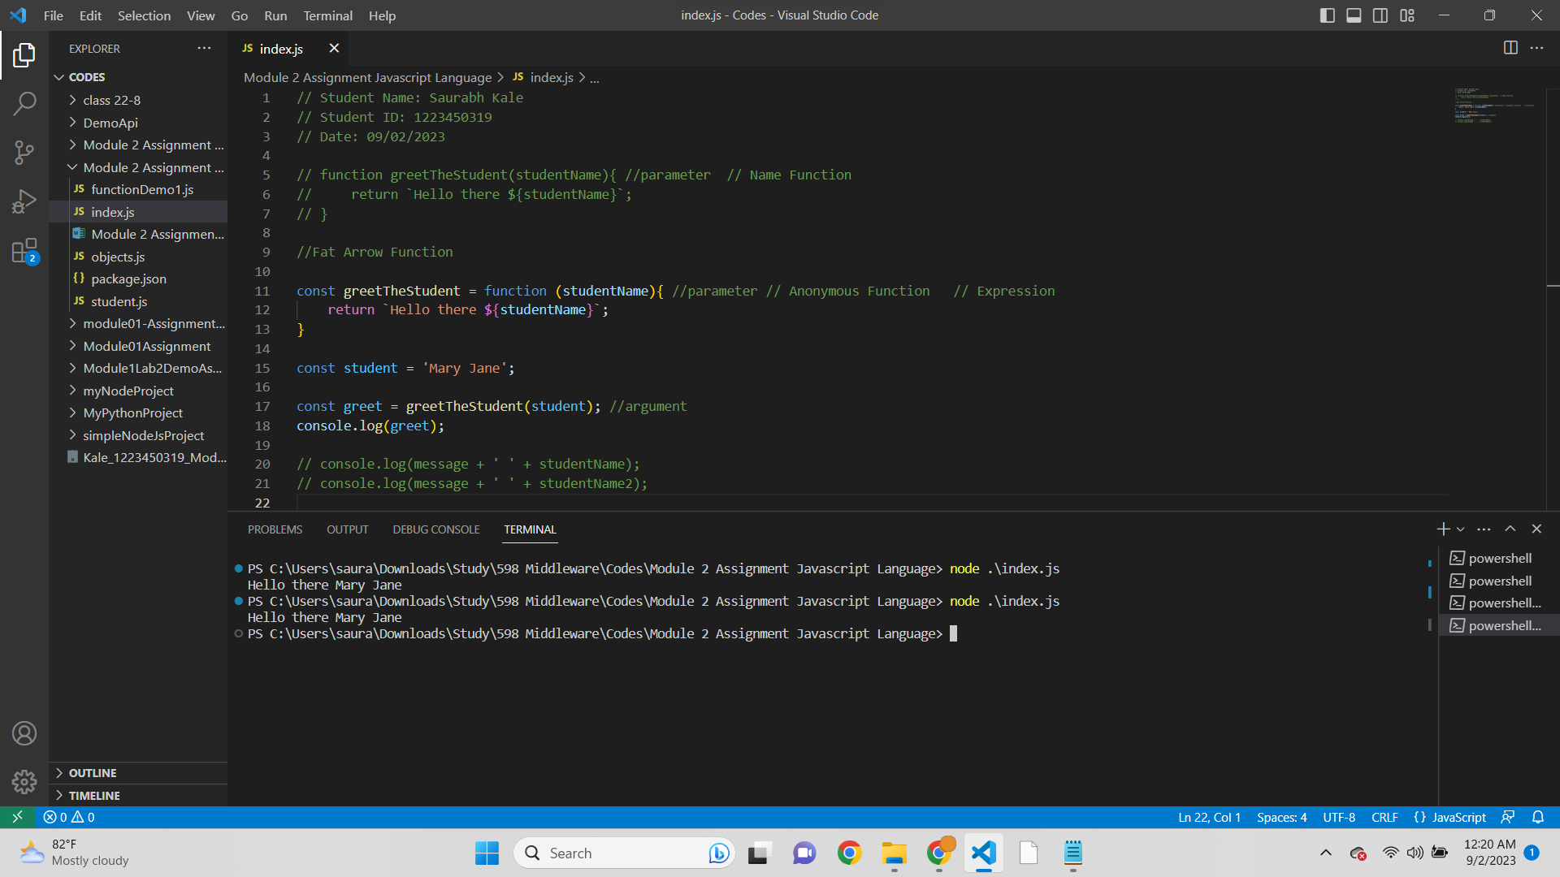

Script-  
// Student Name: Saurabh Kale

// Student ID: 1223450319

// Date: 09/02/2023

// function greetTheStudent(studentName){ //parameter // Name Function

// return `Hello there ${studentName}`;

// }

//Fat Arrow Function

const greetTheStudent = function (studentName){ //parameter // Anonymous Function // Expression

return `Hello there ${studentName}`;

}

const student = 'Mary Jane';

const greet = greetTheStudent(student); //argument

console.log(greet);

// console.log(message + ' ' + studentName);

// console.log(message + ' ' + studentName2);

Output-  
Hello there Mary Jane

* Fat Arrow Function-  
  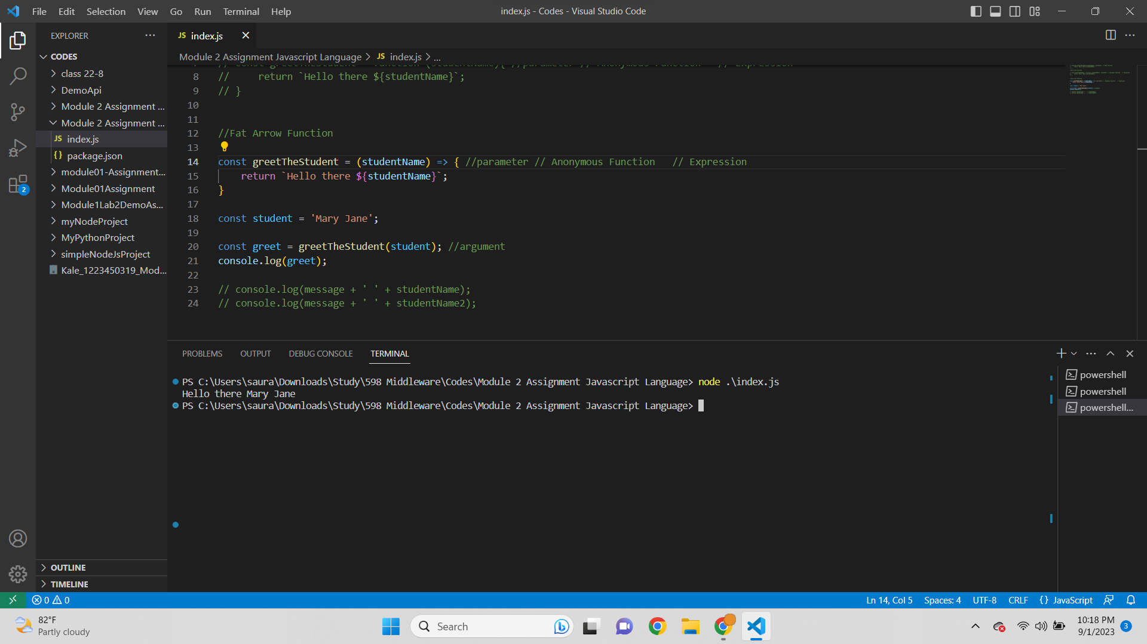

// function greetTheStudent(studentName){ //parameter // Name Function

// return `Hello there ${studentName}`;

// }

//Fat Arrow Function

// const greetTheStudent = function (studentName){ //parameter // Anonymous Function // Expression

// return `Hello there ${studentName}`;

// }

//Fat Arrow Function

const greetTheStudent = (studentName) => { //parameter // Anonymous Function // Expression

return `Hello there ${studentName}`;

}

const student = 'Mary Jane';

const greet = greetTheStudent(student); //argument

console.log(greet);

// console.log(message + ' ' + studentName);

// console.log(message + ' ' + studentName2);

Output-  
Hello there Mary Jane

* One Liner Function-  
  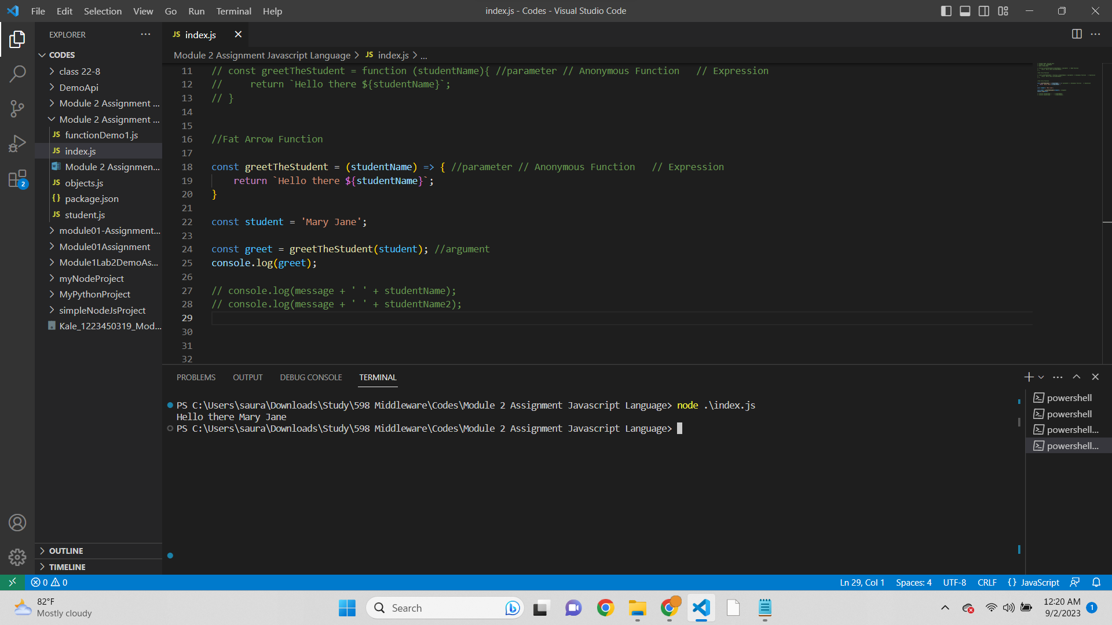

Code-  
// Student Name: Saurabh Kale

// Student ID: 1223450319

// Date: 09/02/2023

// function greetTheStudent(studentName){ //parameter // Name Function

// return `Hello there ${studentName}`;

// }

//Fat Arrow Function

// const greetTheStudent = function (studentName){ //parameter // Anonymous Function // Expression

// return `Hello there ${studentName}`;

// }

//Fat Arrow Function

const greetTheStudent = (studentName) => { //parameter // Anonymous Function // Expression

return `Hello there ${studentName}`;

}

const student = 'Mary Jane';

const greet = greetTheStudent(student); //argument

console.log(greet);

// console.log(message + ' ' + studentName);

// console.log(message + ' ' + studentName2);

Output-  
Hello there Mary Jane

* One Liner Code-

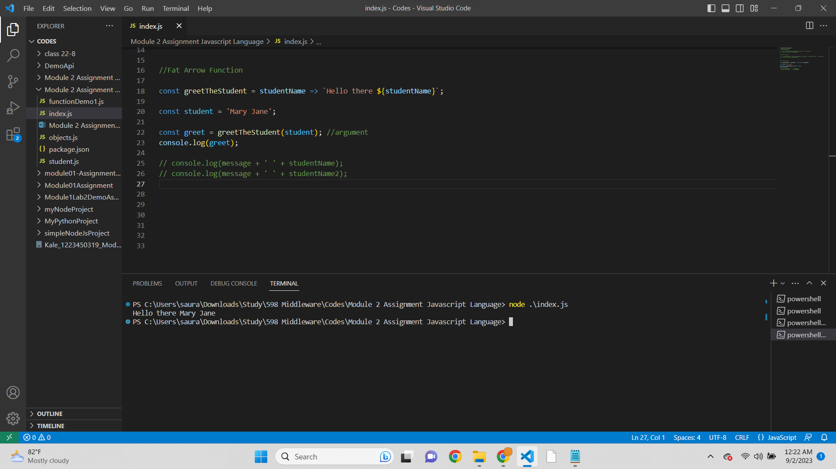

Code-  
// Student Name: Saurabh Kale

// Student ID: 1223450319

// Date: 09/02/2023

// function greetTheStudent(studentName){ //parameter // Name Function

// return `Hello there ${studentName}`;

// }

//Fat Arrow Function

// const greetTheStudent = function (studentName){ //parameter // Anonymous Function // Expression

// return `Hello there ${studentName}`;

// }

//Fat Arrow Function

const greetTheStudent = studentName => `Hello there ${studentName}`;

const student = 'Mary Jane';

const greet = greetTheStudent(student); //argument

console.log(greet);

// console.log(message + ' ' + studentName);

// console.log(message + ' ' + studentName2);

Output-  
Hello there Mary Jane

**JavaScript Refactoring 3**

* Positional Argument-  
  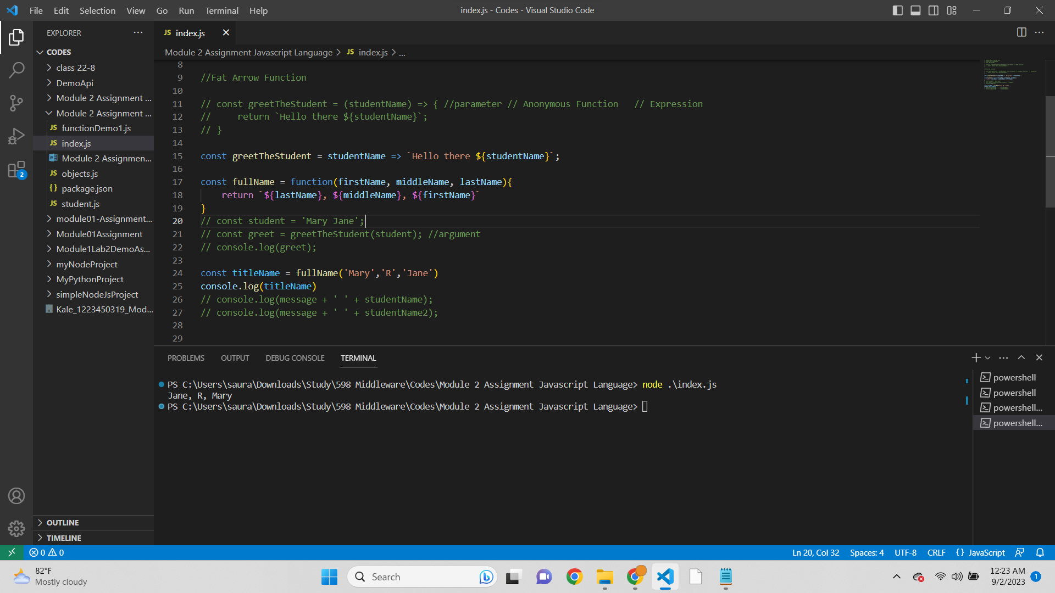

Script-  
// Student Name: Saurabh Kale

// Student ID: 1223450319

// Date: 09/02/2023

// function greetTheStudent(studentName){ //parameter // Name Function

// return `Hello there ${studentName}`;

// }

//Fat Arrow Function

// const greetTheStudent = (studentName) => { //parameter // Anonymous Function // Expression

// return `Hello there ${studentName}`;

// }

const greetTheStudent = studentName => `Hello there ${studentName}`;

const fullName = function(firstName, middleName, lastName){

return `${lastName}, ${middleName}, ${firstName}`

}

// const student = 'Mary Jane';

// const greet = greetTheStudent(student); //argument

// console.log(greet);

const titleName = fullName('Mary','R','Jane')

console.log(titleName)

// console.log(message + ' ' + studentName);

// console.log(message + ' ' + studentName2);

Output-  
Jane, R, Mary

* Arrow Function for positional argument-  
  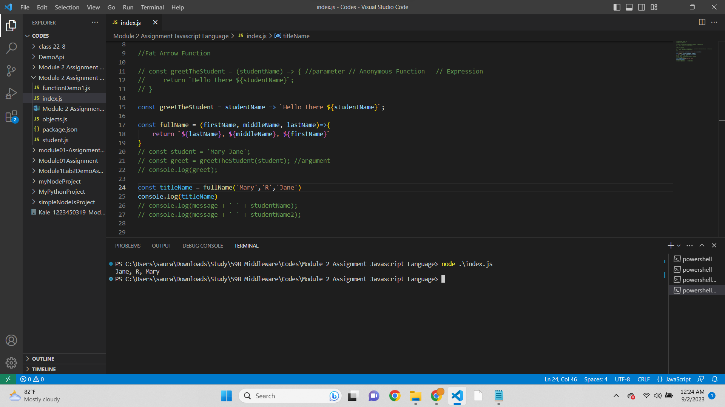

Script-  
// Student Name: Saurabh Kale

// Student ID: 1223450319

// Date: 09/02/2023

// function greetTheStudent(studentName){ //parameter // Name Function

// return `Hello there ${studentName}`;

// }

//Fat Arrow Function

// const greetTheStudent = (studentName) => { //parameter // Anonymous Function // Expression

// return `Hello there ${studentName}`;

// }

const greetTheStudent = studentName => `Hello there ${studentName}`;

const fullName = (firstName, middleName, lastName)=>{

return `${lastName}, ${middleName}, ${firstName}`

}

// const student = 'Mary Jane';

// const greet = greetTheStudent(student); //argument

// console.log(greet);

const titleName = fullName('Mary','R','Jane')

console.log(titleName)

// console.log(message + ' ' + studentName);

// console.log(message + ' ' + studentName2);

Output-  
Jane, R, Mary

* Fat Arrow Function for Positional Argument-  
  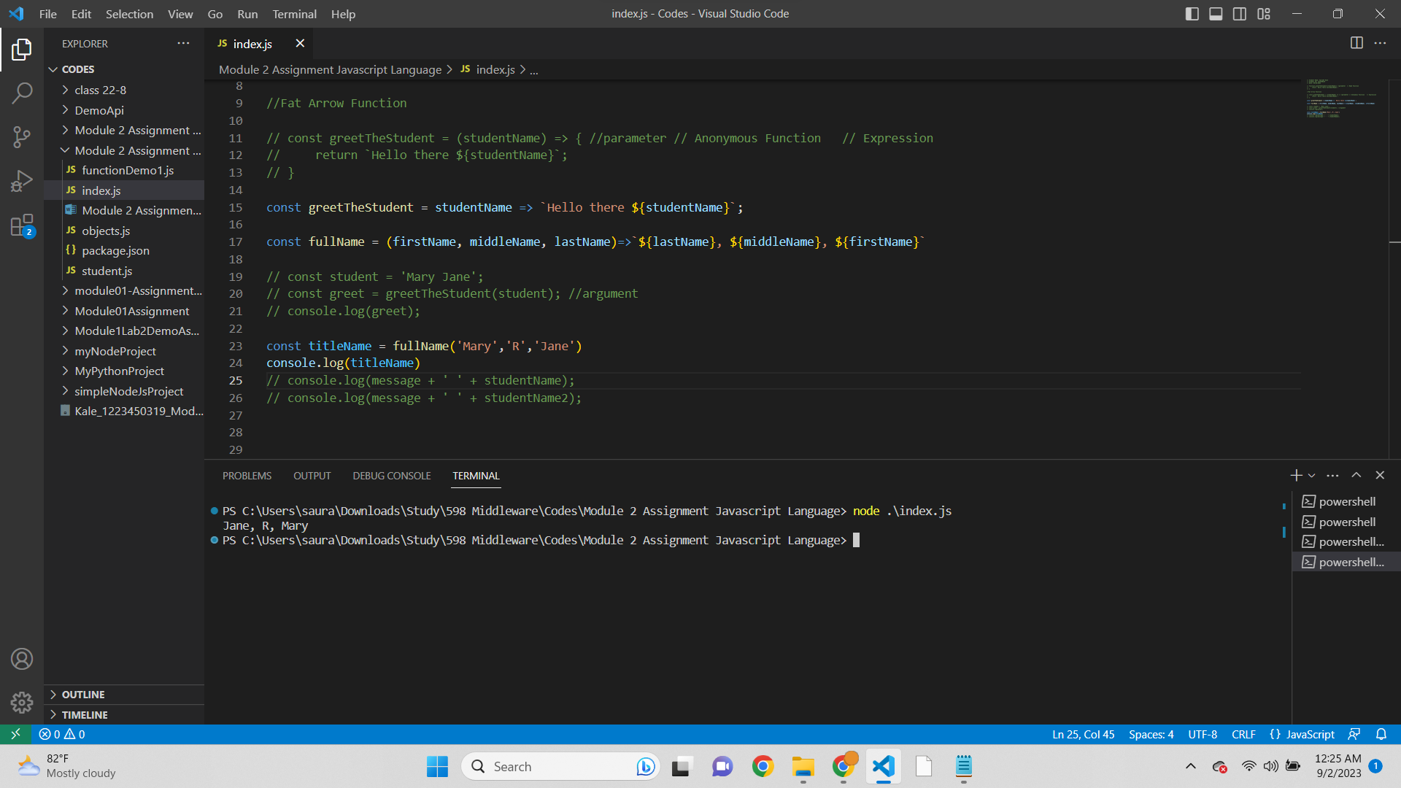

Script-  
// Student Name: Saurabh Kale

// Student ID: 1223450319

// Date: 09/02/2023

// function greetTheStudent(studentName){ //parameter // Name Function

// return `Hello there ${studentName}`;

// }

//Fat Arrow Function

// const greetTheStudent = (studentName) => { //parameter // Anonymous Function // Expression

// return `Hello there ${studentName}`;

// }

const greetTheStudent = studentName => `Hello there ${studentName}`;

const fullName = (firstName, middleName, lastName)=>`${lastName}, ${middleName}, ${firstName}`

// const student = 'Mary Jane';

// const greet = greetTheStudent(student); //argument

// console.log(greet);

const titleName = fullName('Mary','R','Jane')

console.log(titleName)

// console.log(message + ' ' + studentName);

// console.log(message + ' ' + studentName2);

Output-  
Jane, R, Mary

**JavaScript Variables 4**

* Screenshot of Datatype-

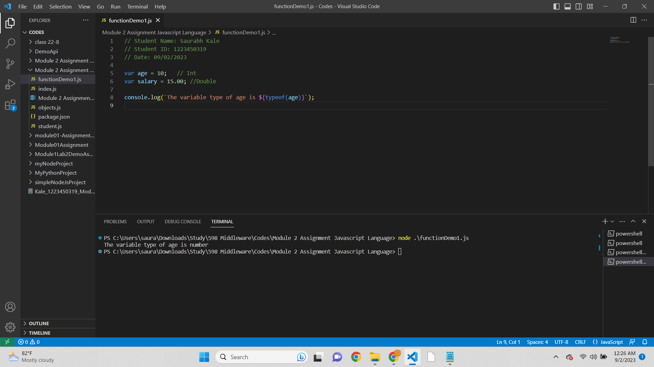

Script-  
// Student Name: Saurabh Kale

// Student ID: 1223450319

// Date: 09/02/2023

var age = 10; // Int

var salary = 15.00; //Double

console.log(`The variable type of age is ${typeof(age)}`);

Output-  
The variable type of age is number

* Screenshot of Datatype for both variables-  
  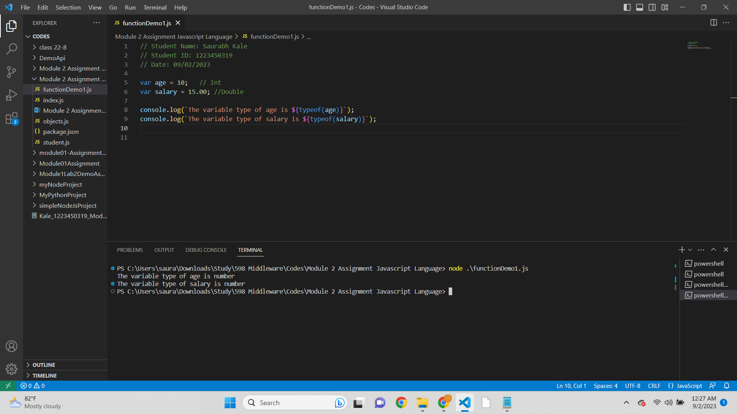

Script-  
// Student Name: Saurabh Kale

// Student ID: 1223450319

// Date: 09/02/2023

var age = 10; // Int

var salary = 15.00; //Double

console.log(`The variable type of age is ${typeof(age)}`);

console.log(`The variable type of salary is ${typeof(salary)}`);

Output-  
The variable type of age is number

The variable type of salary is number

* Screenshot of Datatype Name-  
  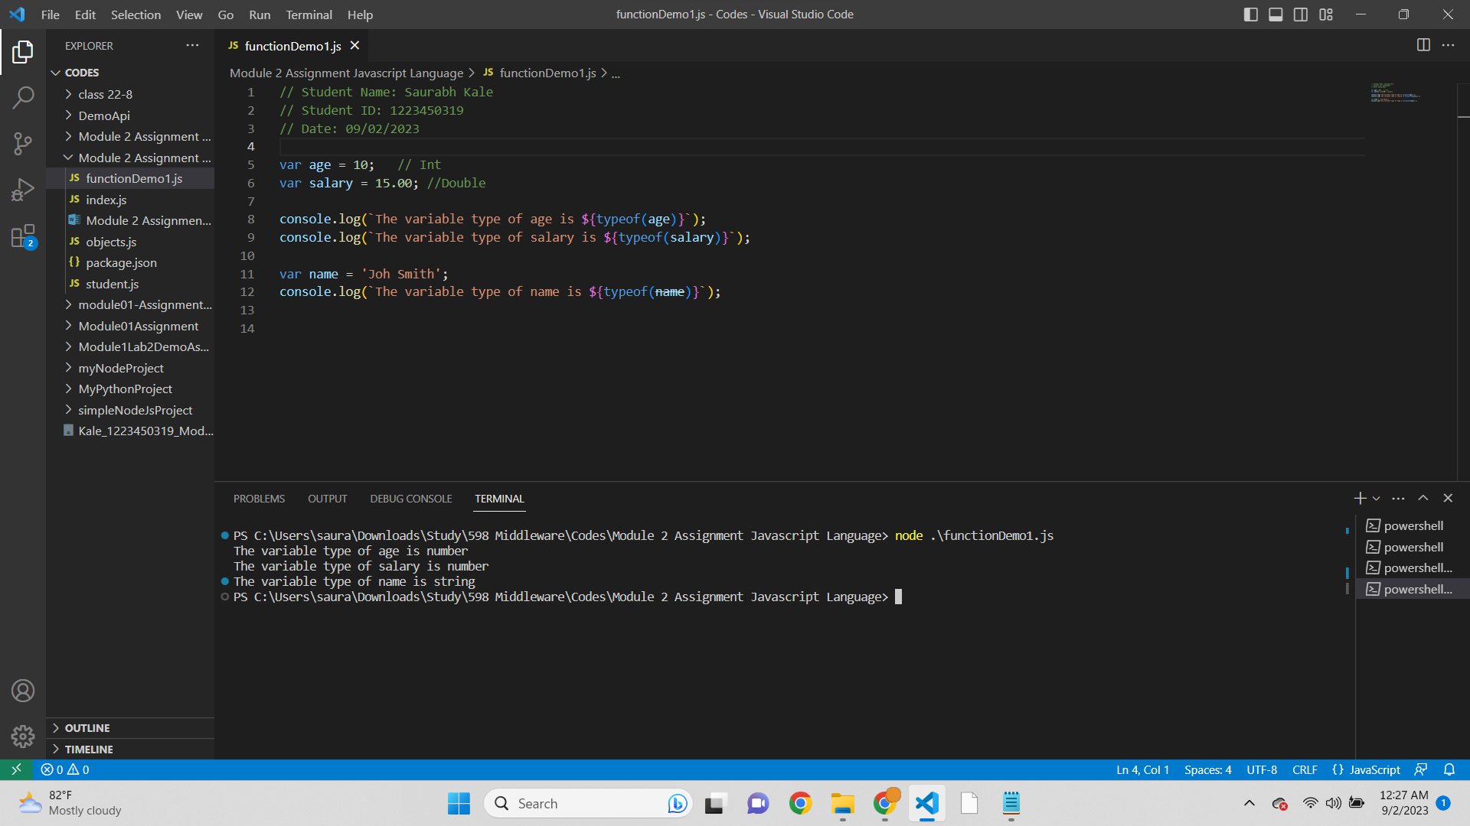

Script-  
// Student Name: Saurabh Kale

// Student ID: 1223450319

// Date: 09/02/2023

var age = 10; // Int

var salary = 15.00; //Double

console.log(`The variable type of age is ${typeof(age)}`);

console.log(`The variable type of salary is ${typeof(salary)}`);

var name = 'Joh Smith';

console.log(`The variable type of name is ${typeof(name)}`);

Output-  
The variable type of age is number

The variable type of salary is number

The variable type of name is string

* Screenshot of variable as function-

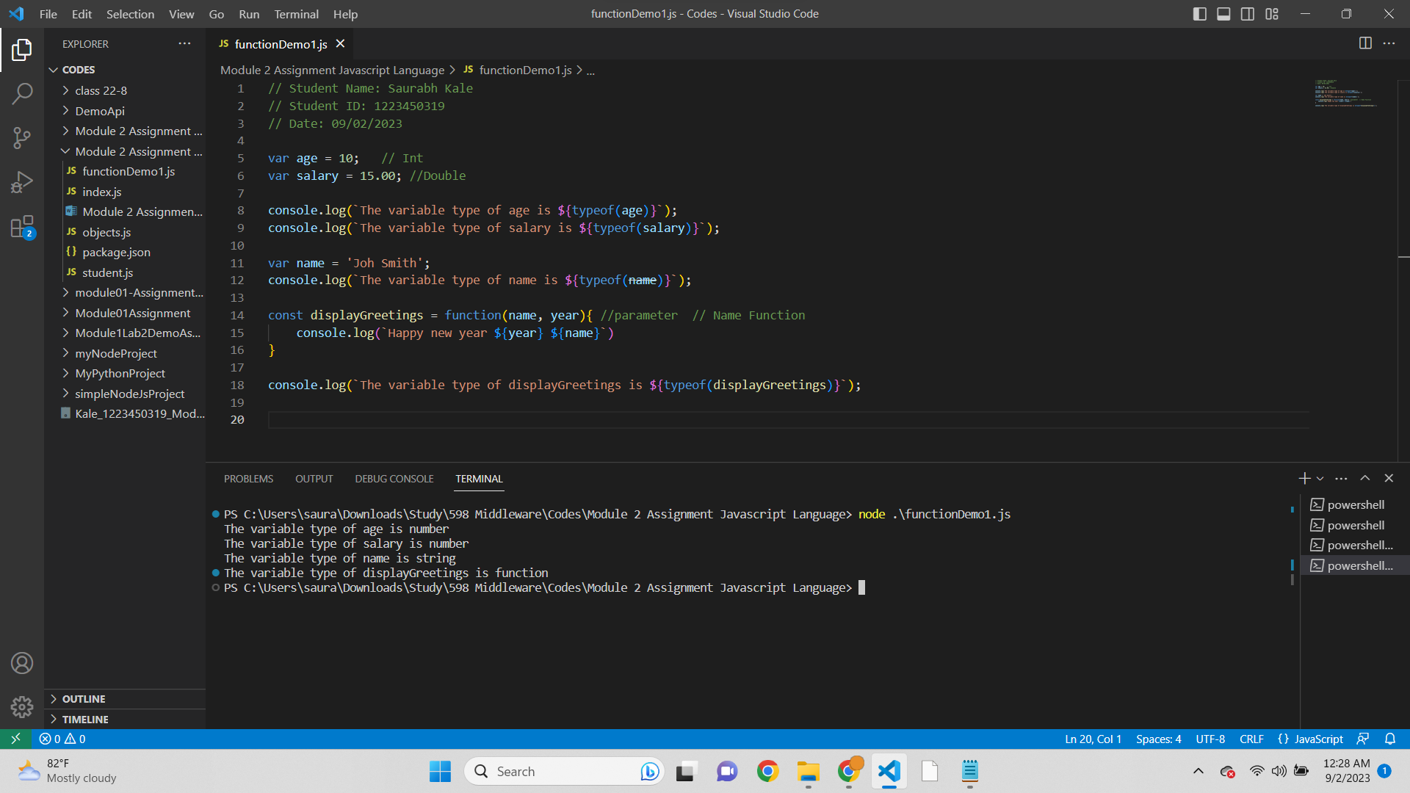

Script-  
// Student Name: Saurabh Kale

// Student ID: 1223450319

// Date: 09/02/2023

var age = 10; // Int

var salary = 15.00; //Double

console.log(`The variable type of age is ${typeof(age)}`);

console.log(`The variable type of salary is ${typeof(salary)}`);

var name = 'Joh Smith';

console.log(`The variable type of name is ${typeof(name)}`);

const displayGreetings = function(name, year){ //parameter // Name Function

console.log(`Happy new year ${year} ${name}`)

}

console.log(`The variable type of displayGreetings is ${typeof(displayGreetings)}`);

Output-  
The variable type of age is number

The variable type of salary is number

The variable type of name is string

The variable type of displayGreetings is function

**JavaScript Objects 5**

* Screenshot of displayGreeting message -

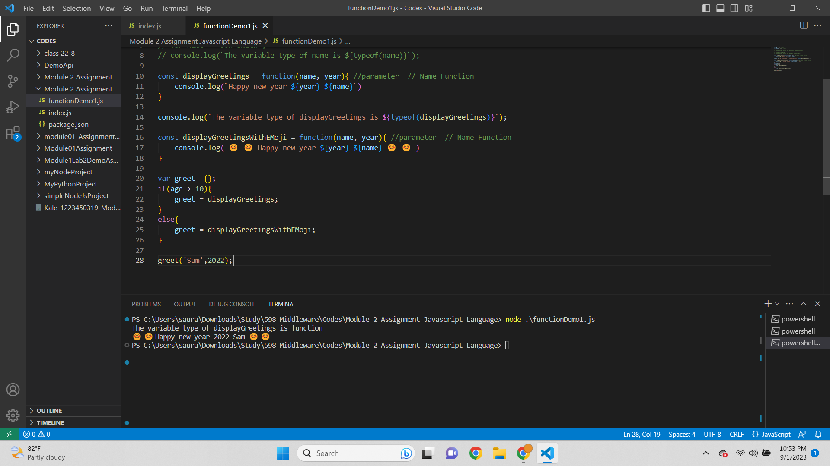

Script-  
// Student Name: Saurabh Kale

// Student ID: 1223450319

// Date: 09/02/2023

var age = 10; // Int

var salary = 15.00; //Double

// console.log(`The variable type of age is ${typeof(age)}`);

// console.log(`The variable type of salary is ${typeof(salary)}`);

// var name = 'Joh Smith';

// console.log(`The variable type of name is ${typeof(name)}`);

const displayGreetings = function(name, year){ //parameter // Name Function

console.log(`Happy new year ${year} ${name}`)

}

console.log(`The variable type of displayGreetings is ${typeof(displayGreetings)}`);

const displayGreetingsWithEMoji = function(name, year){ //parameter // Name Function

console.log(`😊 😊 Happy new year ${year} ${name} 😊 😊`)

}

var greet= {};

if(age > 10){

greet = displayGreetings;

}

else{

greet = displayGreetingsWithEMoji;

}

greet('Sam',2022);

Output-  
The variable type of displayGreetings is function

😊 😊 Happy new year 2022 Sam 😊 😊

**JavaScript Parameter (Function as a parameter) 6**

* Screenshot of Function calling using variable function-

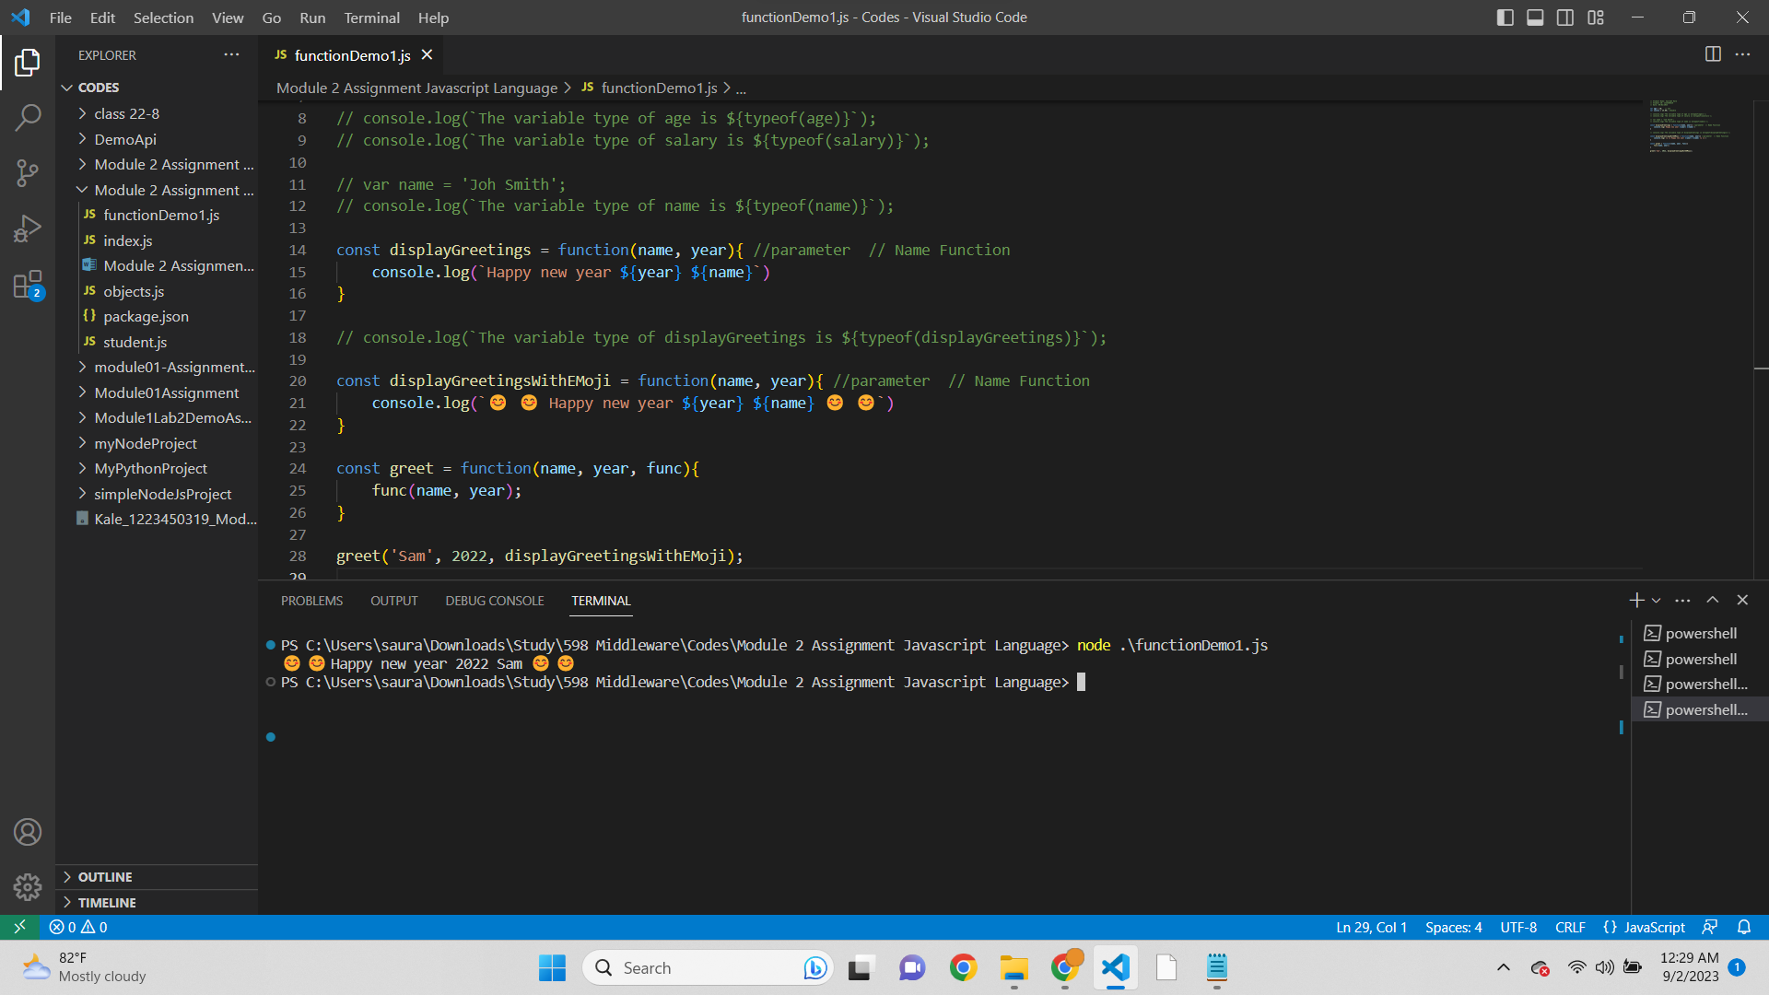

Script-  
// Student Name: Saurabh Kale

// Student ID: 1223450319

// Date: 09/02/2023

var age = 10; // Int

var salary = 15.00; //Double

// console.log(`The variable type of age is ${typeof(age)}`);

// console.log(`The variable type of salary is ${typeof(salary)}`);

// var name = 'Joh Smith';

// console.log(`The variable type of name is ${typeof(name)}`);

const displayGreetings = function(name, year){ //parameter // Name Function

console.log(`Happy new year ${year} ${name}`)

}

// console.log(`The variable type of displayGreetings is ${typeof(displayGreetings)}`);

const displayGreetingsWithEMoji = function(name, year){ //parameter // Name Function

console.log(`😊 😊 Happy new year ${year} ${name} 😊 😊`)

}

const greet = function(name, year, func){

func(name, year);

}

greet('Sam', 2022, displayGreetingsWithEMoji);

Output-  
😊 😊 Happy new year 2022 Sam 😊 😊

* Screenshot of displaying displayGreetings-  
  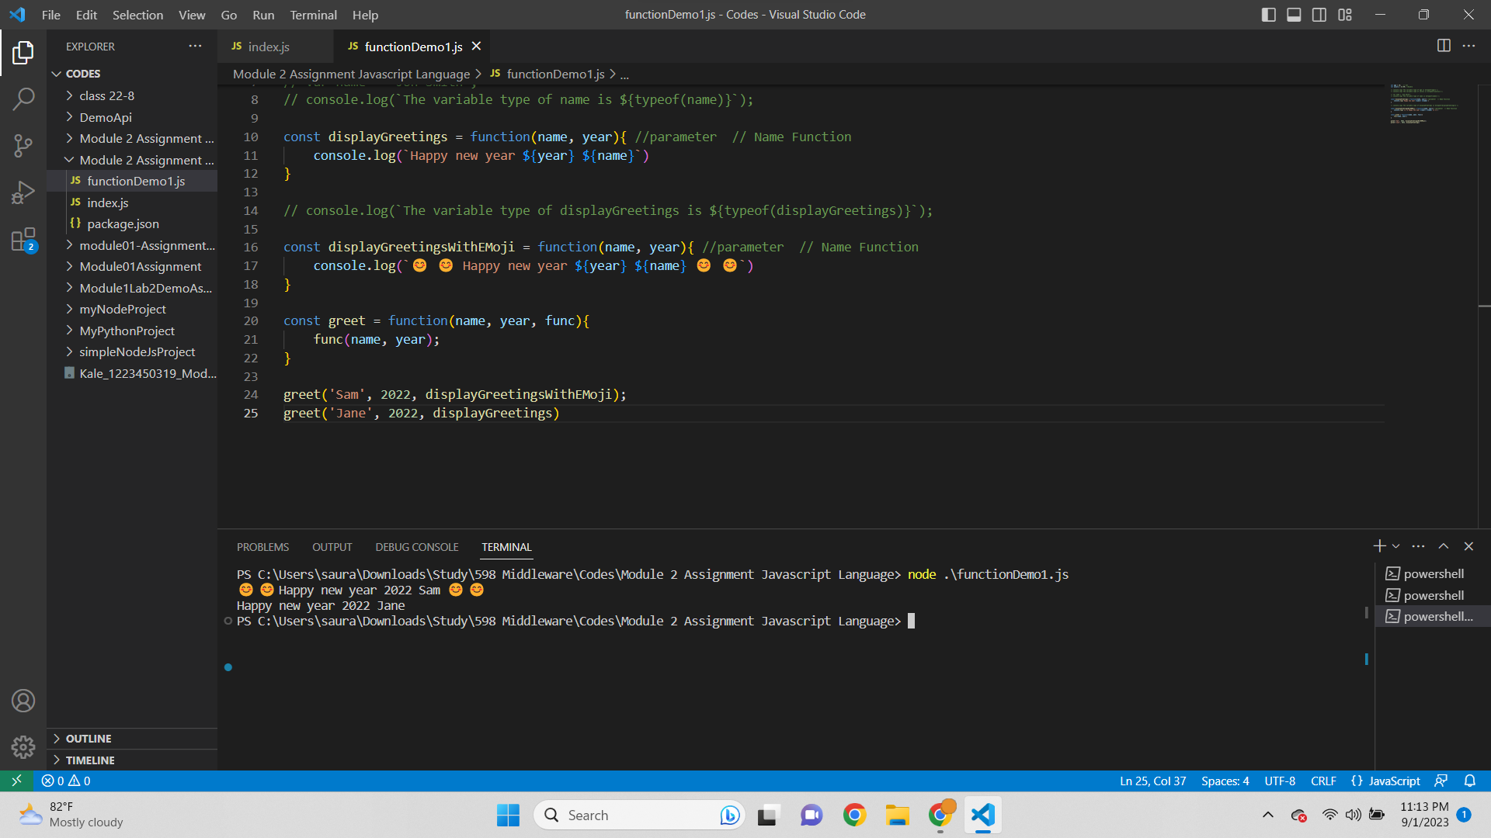

Script-  
var age = 10; // Int

var salary = 15.00; //Double

// console.log(`The variable type of age is ${typeof(age)}`);

// console.log(`The variable type of salary is ${typeof(salary)}`);

// var name = 'Joh Smith';

// console.log(`The variable type of name is ${typeof(name)}`);

const displayGreetings = function(name, year){ //parameter // Name Function

console.log(`Happy new year ${year} ${name}`)

}

// console.log(`The variable type of displayGreetings is ${typeof(displayGreetings)}`);

const displayGreetingsWithEMoji = function(name, year){ //parameter // Name Function

console.log(`😊 😊 Happy new year ${year} ${name} 😊 😊`)

}

const greet = function(name, year, func){

func(name, year);

}

greet('Sam', 2022, displayGreetingsWithEMoji);

greet('Jane', 2022, displayGreetings)

Output-  
😊 😊 Happy new year 2022 Sam 😊 😊

Happy new year 2022 Jane

**JavaScript Objects II 8**

* Screenshot of array first element-  
  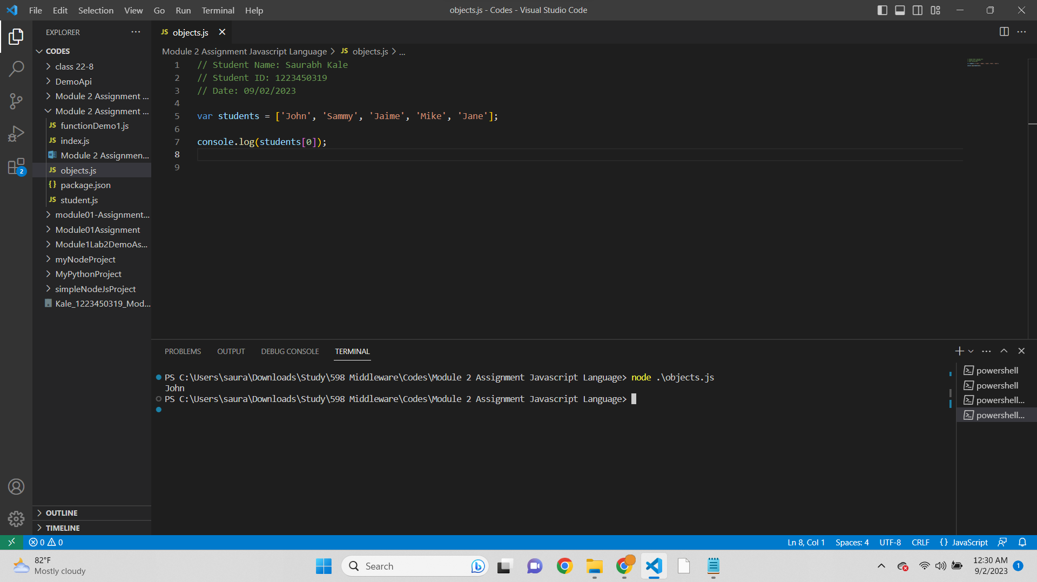

Script-  
// Student Name: Saurabh Kale

// Student ID: 1223450319

// Date: 09/02/2023

var students = ['John', 'Sammy', 'Jaime', 'Mike', 'Jane'];

console.log(students[0]);

Output-  
John

* Screenshot of length of an array-  
  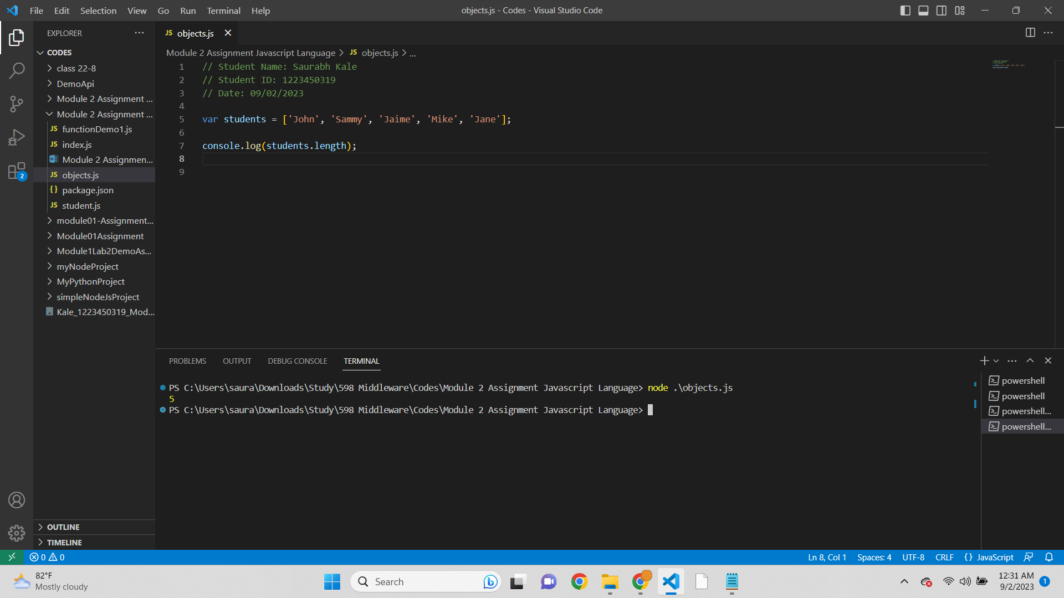

Script-  
// Student Name: Saurabh Kale

// Student ID: 1223450319

// Date: 09/02/2023

var students = ['John', 'Sammy', 'Jaime', 'Mike', 'Jane'];

console.log(students.length);

Output-  
5

* Screenshot of array of grades-  
  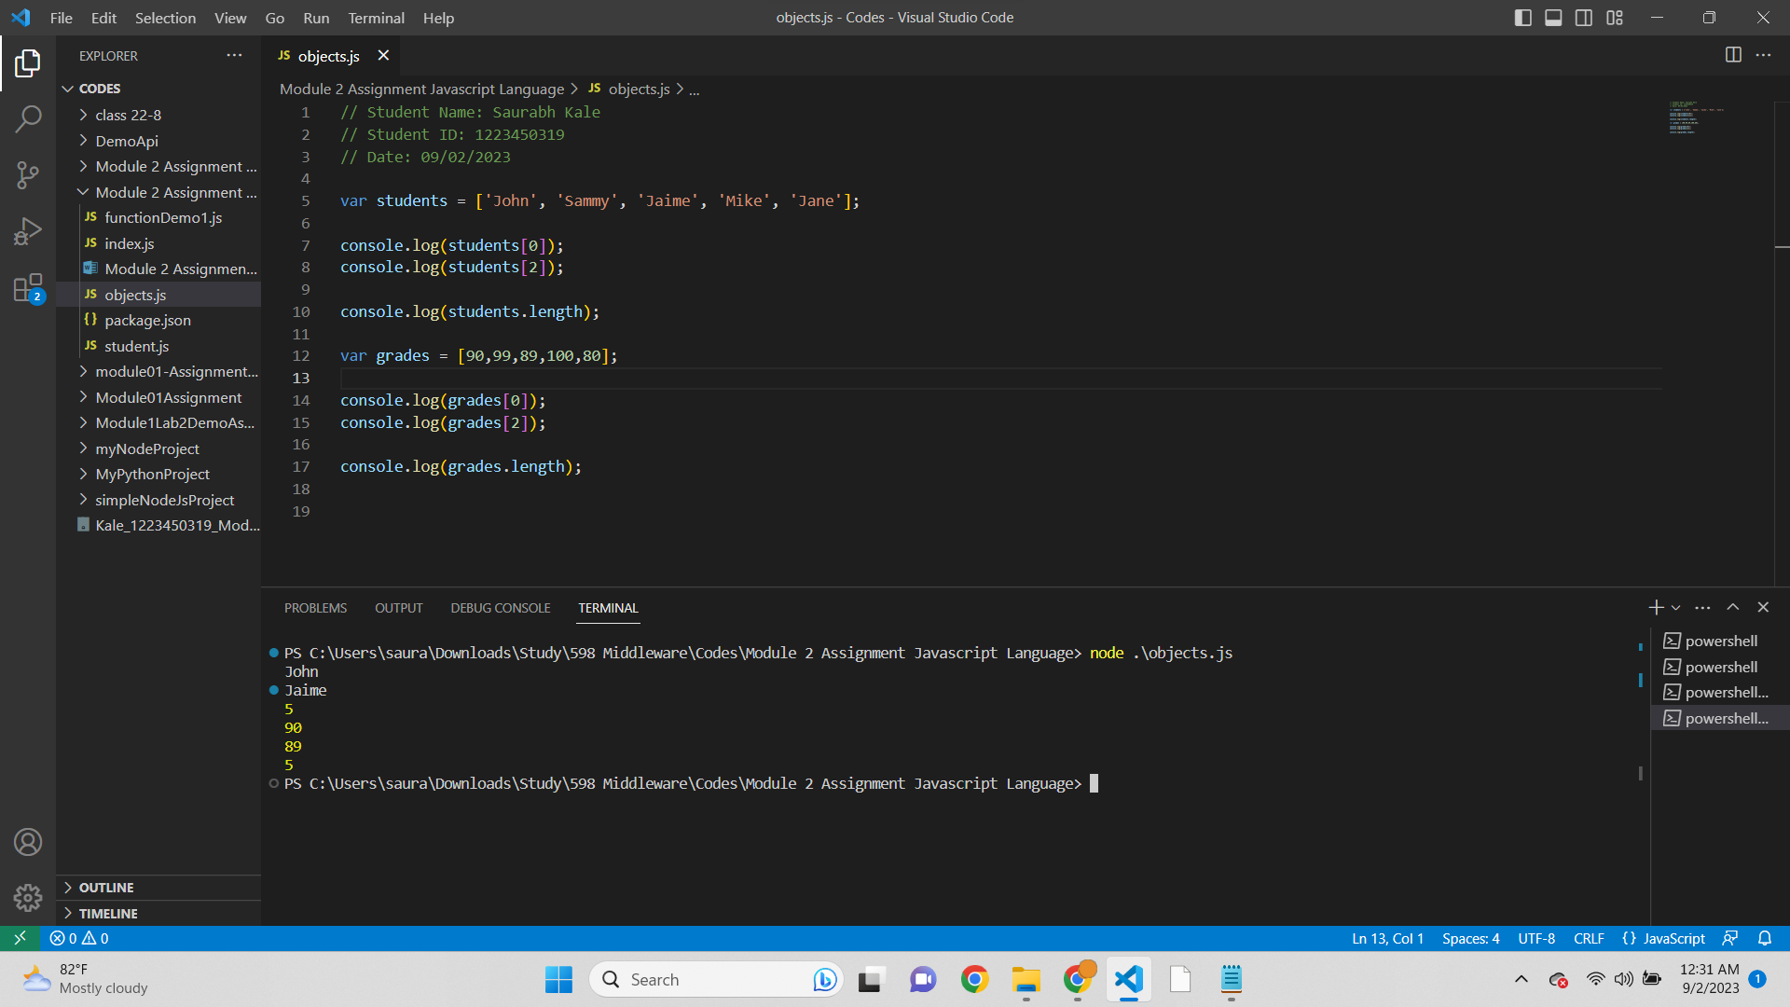

Script-  
// Student Name: Saurabh Kale

// Student ID: 1223450319

// Date: 09/02/2023

var students = ['John', 'Sammy', 'Jaime', 'Mike', 'Jane'];

console.log(students[0]);

console.log(students[2]);

console.log(students.length);

var grades = [90,99,89,100,80];

console.log(grades[0]);

console.log(grades[2]);

console.log(grades.length);

Output-  
John

Jaime

5

90

89

5

* Screenshot of Last element and second last element of array-  
  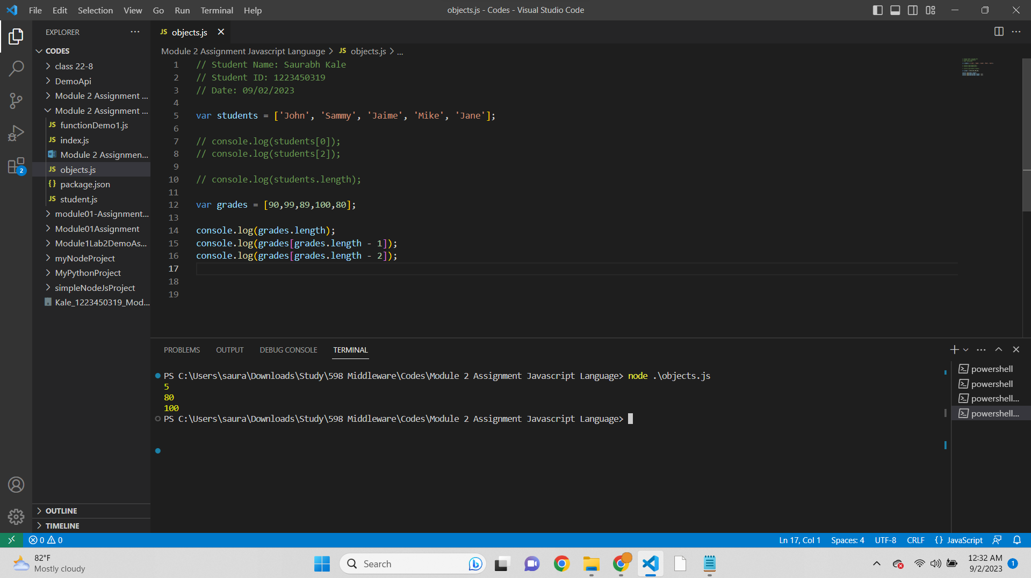

Script-

// Student Name: Saurabh Kale

// Student ID: 1223450319

// Date: 09/02/2023

var students = ['John', 'Sammy', 'Jaime', 'Mike', 'Jane'];

// console.log(students[0]);

// console.log(students[2]);

// console.log(students.length);

var grades = [90,99,89,100,80];

console.log(grades.length);

console.log(grades[grades.length - 1]);

console.log(grades[grades.length - 2]);

Output-  
5

80

100

**JavaScripts Arrays 9**

* Screenshot of Name of student in Object printed-  
  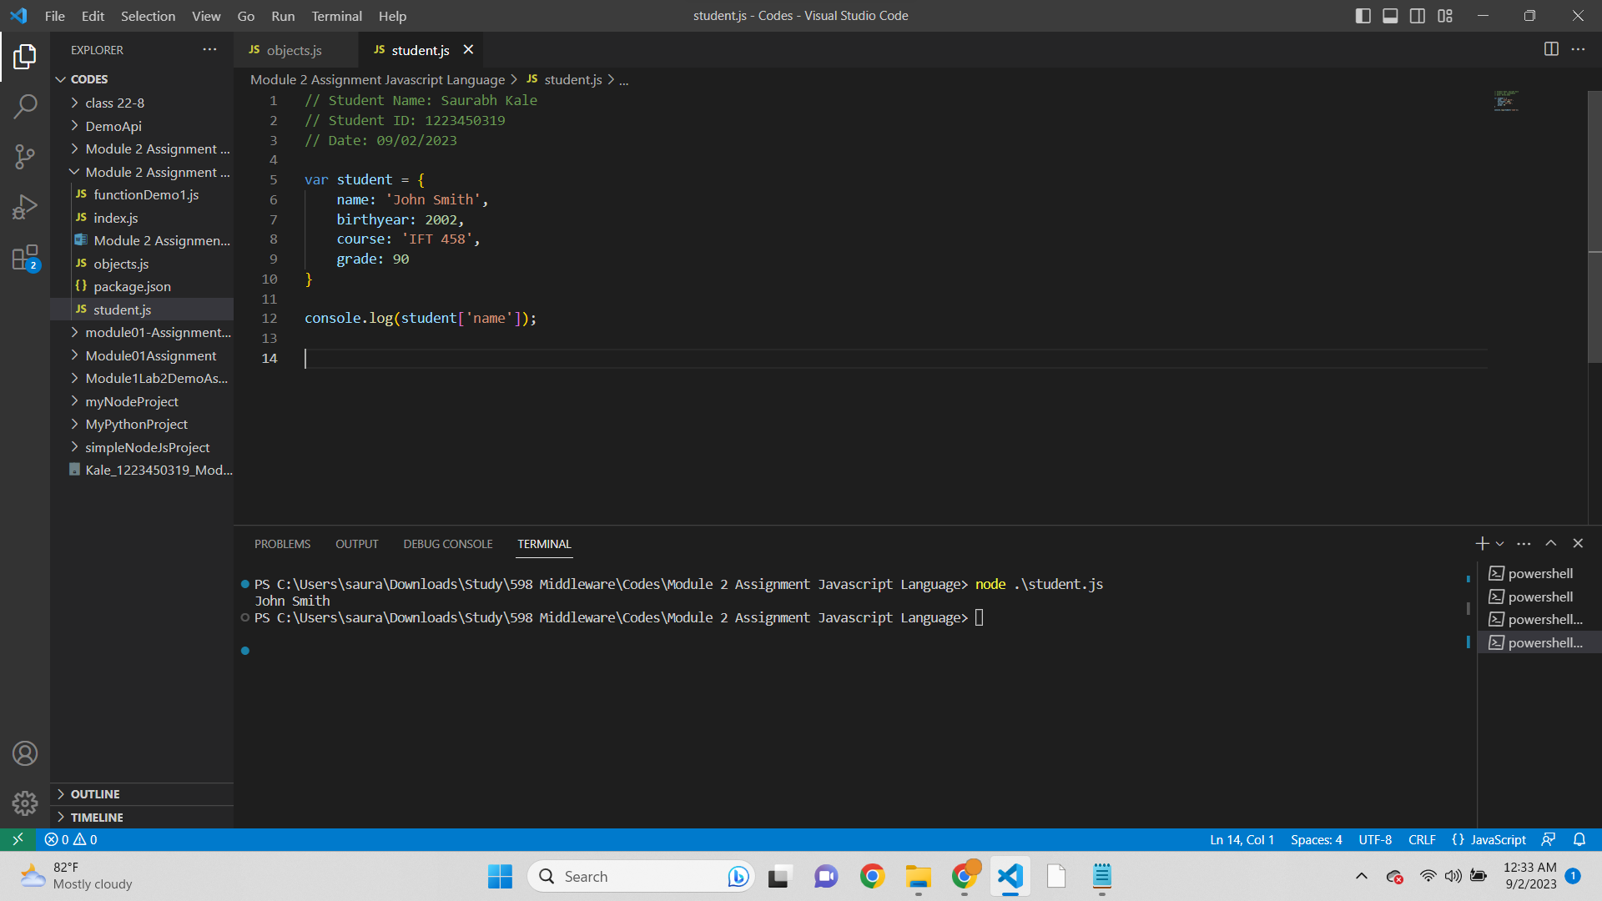

Script-  
// Student Name: Saurabh Kale

// Student ID: 1223450319

// Date: 09/02/2023

var student = {

name: 'John Smith',

birthyear: 2002,

course: 'IFT 458',

grade: 90

}

console.log(student['name']);

Output-  
John Smith

* Old way to print name of student in object-  
  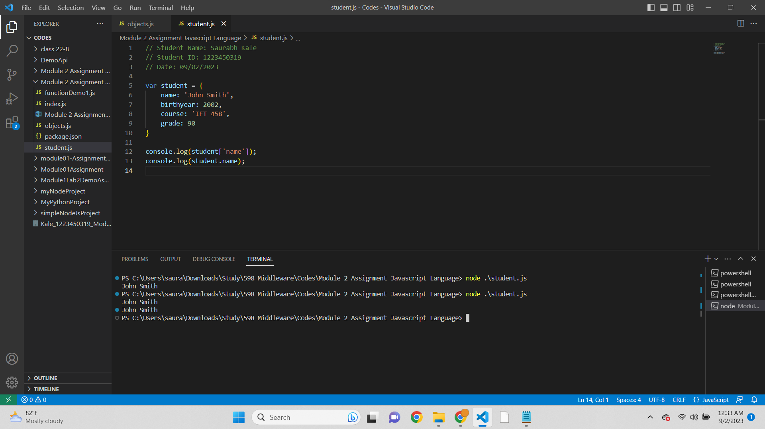

Script-

// Student Name: Saurabh Kale

// Student ID: 1223450319

// Date: 09/02/2023

var student = {

name: 'John Smith',

birthyear: 2002,

course: 'IFT 458',

grade: 90

}

console.log(student['name']);

console.log(student.name);

Output-  
John Smith

* Screenshot of Student2 age function displaying age-  
  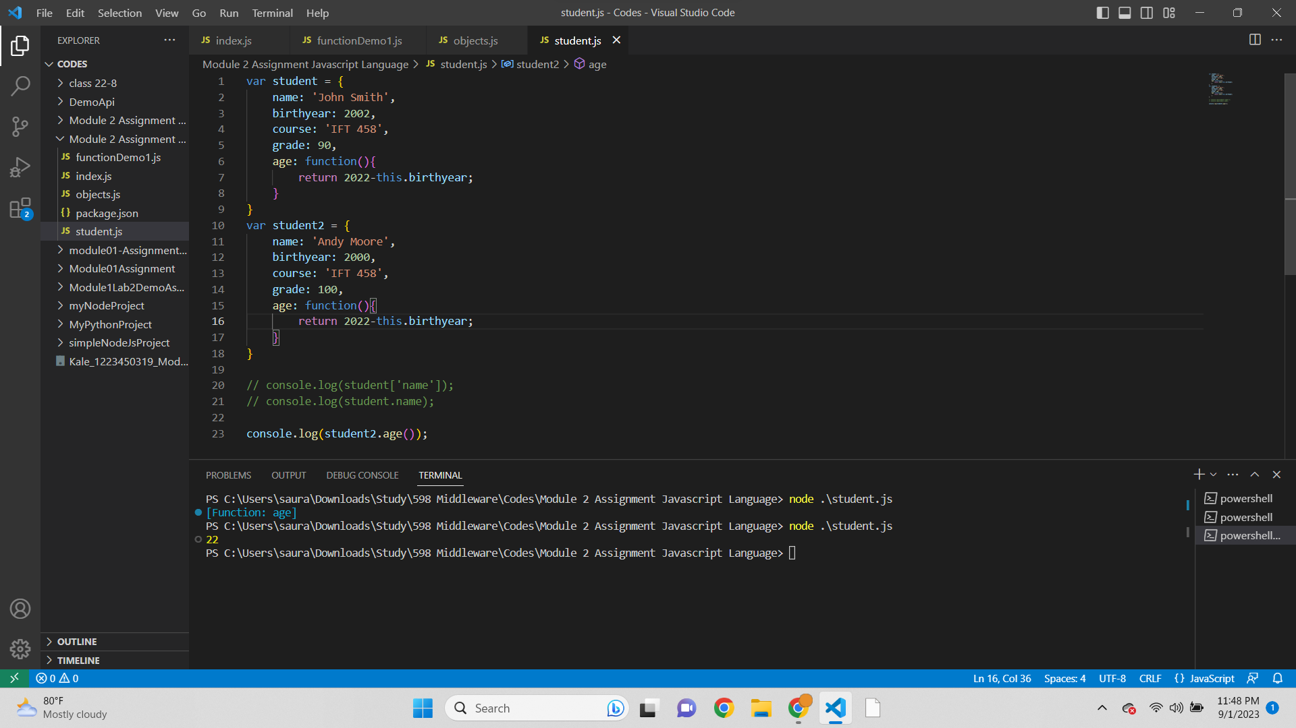

Script-

// Student Name: Saurabh Kale

// Student ID: 1223450319

// Date: 09/02/2023

var student = {

name: 'John Smith',

birthyear: 2002,

course: 'IFT 458',

grade: 90,

age: function(){

return 2022-this.birthyear;

}

}

var student2 = {

name: 'Andy Moore',

birthyear: 2000,

course: 'IFT 458',

grade: 100,

age: function(){

return 2022-this.birthyear;

}

}

// console.log(student['name']);

// console.log(student.name);

console.log(student2.age());

Output-  
22

* Screenshot of Displaying age of 2 students-  
  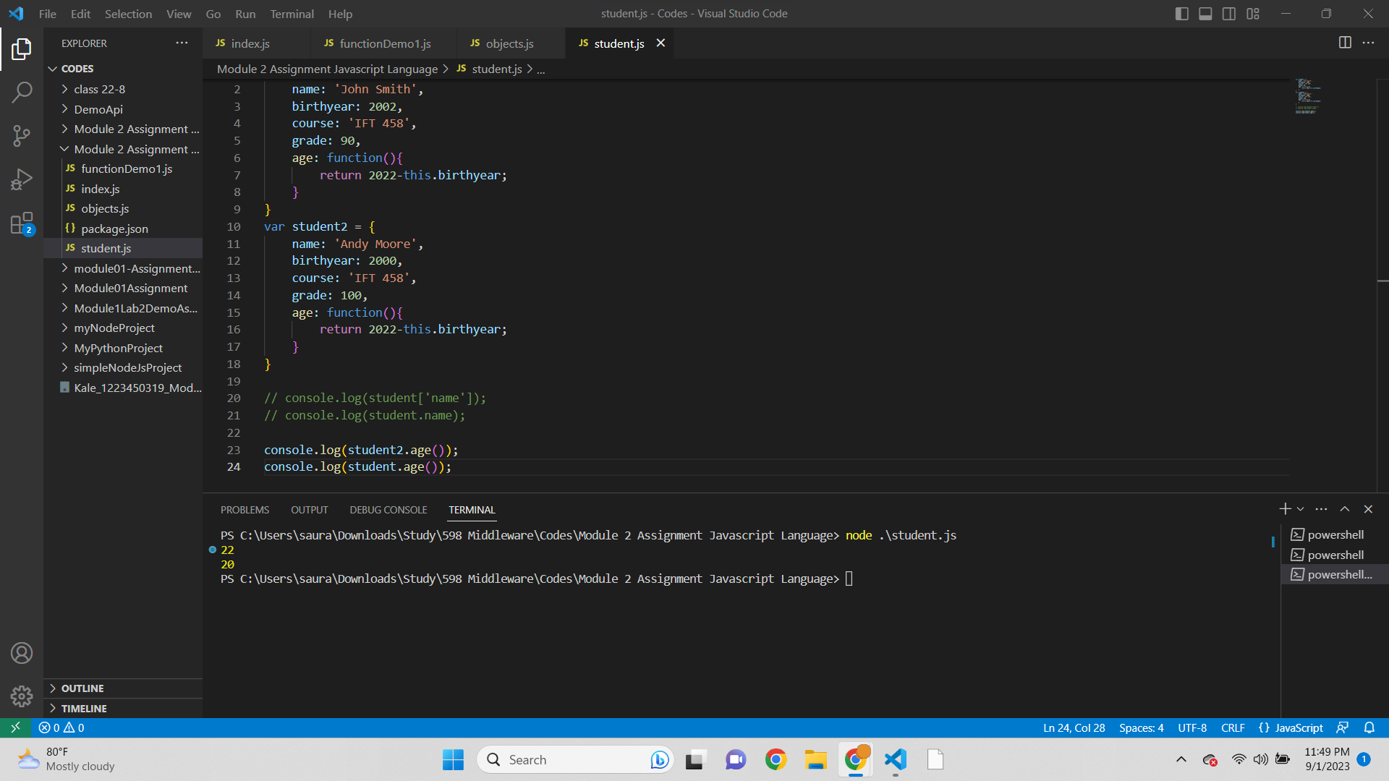

Script-

// Student Name: Saurabh Kale

// Student ID: 1223450319

// Date: 09/02/2023

var student = {

name: 'John Smith',

birthyear: 2002,

course: 'IFT 458',

grade: 90,

age: function(){

return 2022-this.birthyear;

}

}

var student2 = {

name: 'Andy Moore',

birthyear: 2000,

course: 'IFT 458',

grade: 100,

age: function(){

return 2022-this.birthyear;

}

}

// console.log(student['name']);

// console.log(student.name);

console.log(student2.age());

console.log(student.age());

Output-  
22

20

* Screenshot of Active and Inactive logic for calculating age-  
  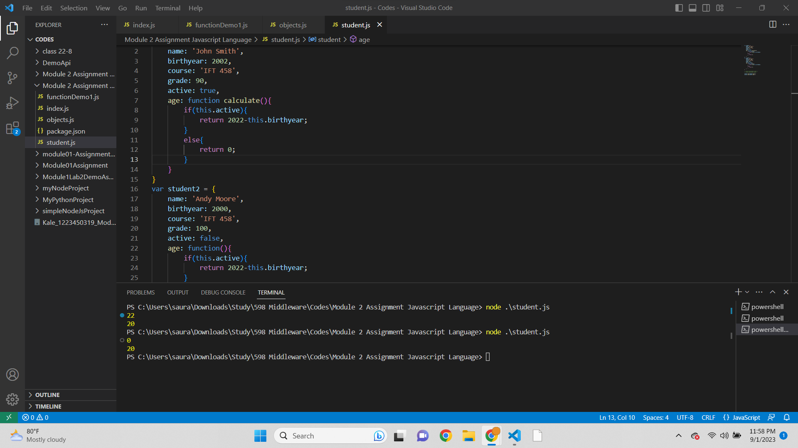

Script-

// Student Name: Saurabh Kale

// Student ID: 1223450319

// Date: 09/02/2023

var student = {

name: 'John Smith',

birthyear: 2002,

course: 'IFT 458',

grade: 90,

active: true,

age: function calculate(){

if(this.active){

return 2022-this.birthyear;

}

else{

return 0;

}

}

}

var student2 = {

name: 'Andy Moore',

birthyear: 2000,

course: 'IFT 458',

grade: 100,

active: false,

age: function(){

if(this.active){

return 2022-this.birthyear;

}

else{

return 0;

}

}

}

// console.log(student['name']);

// console.log(student.name);

console.log(student2.age());

console.log(student.age());

Output-

0

20

**Accessing Elements of JavaScript Object Arrays 10**

* Student objects passed in array-  
  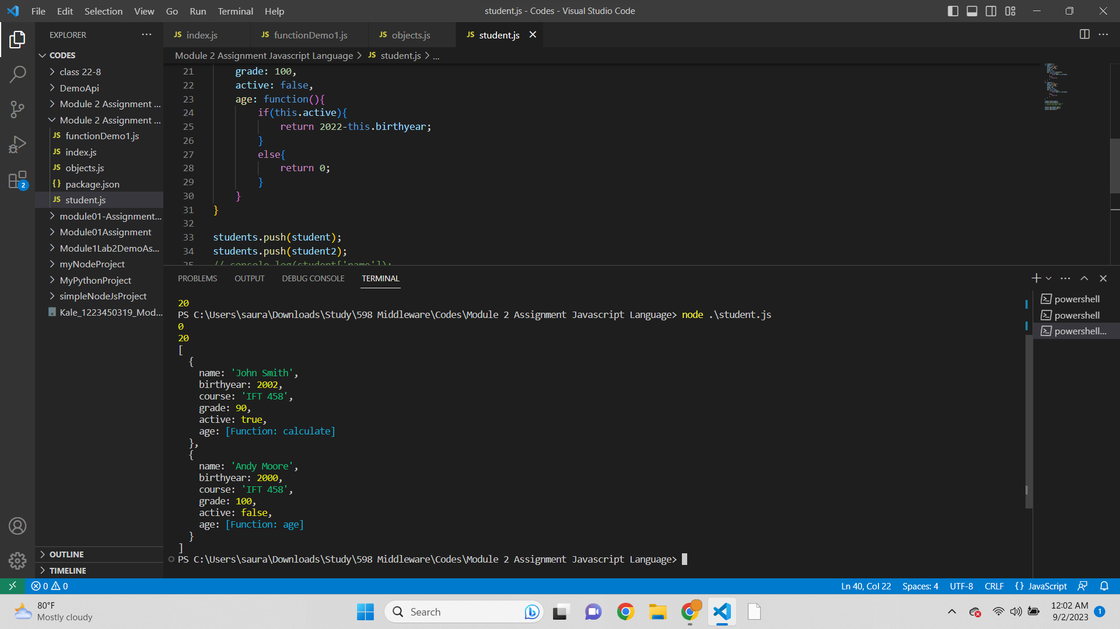

Script-

// Student Name: Saurabh Kale

// Student ID: 1223450319

// Date: 09/02/2023

var students= [];

var student = {

name: 'John Smith',

birthyear: 2002,

course: 'IFT 458',

grade: 90,

active: true,

age: function calculate(){

if(this.active){

return 2022-this.birthyear;

}

else{

return 0;

}

}

}

var student2 = {

name: 'Andy Moore',

birthyear: 2000,

course: 'IFT 458',

grade: 100,

active: false,

age: function(){

if(this.active){

return 2022-this.birthyear;

}

else{

return 0;

}

}

}

students.push(student);

students.push(student2);

// console.log(student['name']);

// console.log(student.name);

console.log(student2.age());

console.log(student.age());

console.log(students)

Output-  
0

20

[

{

name: 'John Smith',

birthyear: 2002,

course: 'IFT 458',

grade: 90,

active: true,

age: [Function: calculate]

},

{

name: 'Andy Moore',

birthyear: 2000,

course: 'IFT 458',

grade: 100,

active: false,

age: [Function: age]

}

]

* Screenshot of using forEach for students array-  
  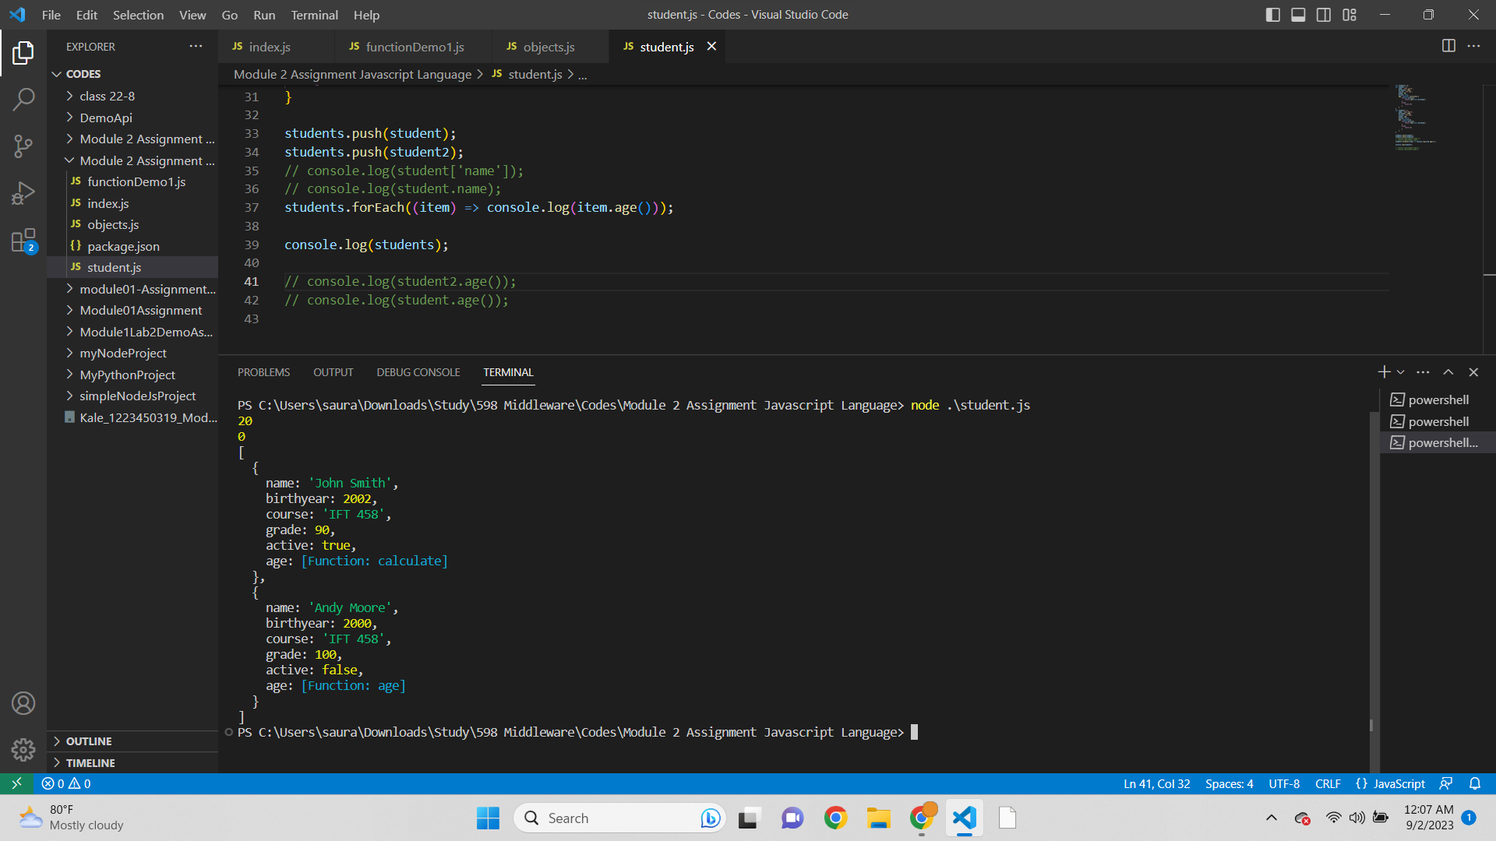

Script-  
// Student Name: Saurabh Kale

// Student ID: 1223450319

// Date: 09/02/2023

var students= [];

var student = {

name: 'John Smith',

birthyear: 2002,

course: 'IFT 458',

grade: 90,

active: true,

age: function calculate(){

if(this.active){

return 2022-this.birthyear;

}

else{

return 0;

}

}

}

var student2 = {

name: 'Andy Moore',

birthyear: 2000,

course: 'IFT 458',

grade: 100,

active: false,

age: function(){

if(this.active){

return 2022-this.birthyear;

}

else{

return 0;

}

}

}

students.push(student);

students.push(student2);

// console.log(student['name']);

// console.log(student.name);

students.forEach((item) => console.log(item.age()));

console.log(students);

// console.log(student2.age());

// console.log(student.age());

Output-  
20

0

[

{

name: 'John Smith',

birthyear: 2002,

course: 'IFT 458',

grade: 90,

active: true,

age: [Function: calculate]

},

{

name: 'Andy Moore',

birthyear: 2000,

course: 'IFT 458',

grade: 100,

active: false,

age: [Function: age]

}

]

* Screenshot of Git file uploaded

